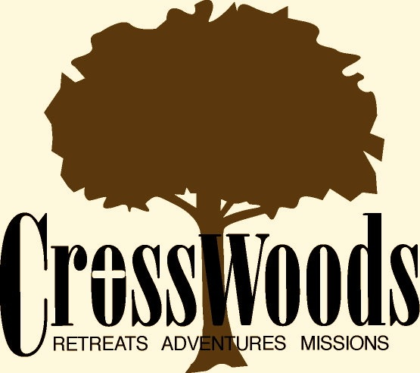
Participant Name:__________________________
Birthday:__________________________
Camper/Parent Authorizations – CrossWoods Adventure Camp, Inc.

Section A: Camper Authorization
- I understand and agree to cooperate with all regulations regarding behavior, health, special qualifications and age.
- I authorize an adult, in whose care I have been entrusted, to consent to X-ray examination, anesthetic, medical, surgical or dental diagnosis and treatment or hospital care, to be rendered to me under the general or specific supervision and on the advice of any physician or dentist licensed under the provisions of the Medical Practice Act. If I am not a minor, I will be liable and agree to pay all costs and expenses incurred in connection with such medical and dental services rendered to me pursuant to this authorization.
- I understand the general guidelines of behavior: I must respect and obey instructions of the adult(s) in charge and that no smoking, alcohol, illegal drugs, possession of weapons, or sexual misconduct is tolerated. I will assume all transportation costs if problems occur during any event or activity.
- I will take no civil action against the CrossWoods staff, any associated agencies, or persons in whose care I have been entrusted, for my normal care.
- I give my permission for photographs or video footage of me to be used by CrossWoods, for promotional purposes, unless I initial here _____ (initialing means you do NOT give permission).
- I give my permission for my address/phone number/email address to be included on a participant roster of the camp for use of campers and staff only, unless I initial here _____ (initialing means you do NOT give permission).

________________________________________________________________________________________________
Signature of Camper Printed Name of Camper Date

Section B: Parent/Guardian Authorization and Authorized Rides (Must be signed by the camper’s parent/guardian if the camper is under the age of 18 on the first day of camp)
- I give full permission to this minor to attend the youth event at CrossWoods Camp.
- I give full permission to this minor to participate in all activities at CrossWoods Camp, unless otherwise specified on the Health History Form.
- I authorize an adult, in whose care the minor has been entrusted, to consent to X-ray examination, anesthetic, medical, surgical or dental diagnosis and treatment or hospital care, to be rendered to the minor under the general or specific supervision and on the advice of any physician or dentist licensed under the provisions of the Medical Practice Act, if there is insufficient time or inability to contact me. I will be liable and agree to pay all costs and expenses incurred in connection with such medical and dental services rendered to the above named minor pursuant to this authorization.
- I give permission for this minor to ride in any vehicle designated by the adult in whose care the minor has been entrusted while participating in events at CrossWoods Camp.
- I understand the general guidelines of behavior: the minor must respect and obey instructions of the adult(s) in charge and that no smoking, alcohol, illegal drugs, possession of weapons or sexual misconduct is tolerated. I will assume all transportation costs for this minor if problems occur during any event or activity.
- I will take no civil action against CrossWoods staff, any associated agencies, or persons in whose care the minor has been entrusted, for normal care of the minor in their charge.
- I give my permission for photographs or video footage of my child to be used by CrossWoods, for promotional purposes, unless I initial here _____ (initialing means you do NOT give permission).
- I give my permission for my child’s address/phone number to be included on a participant roster of the camp for use of campers and staff only, unless I initial here _____ (initialing means you do NOT give permission).
- I have also read and consent to all the items printed in Section A of this form.

Authorized Rides: Please check one or more of the following boxes as appropriate.
 Only the following people may pick up the above named camper: _______________________________________________________________ ______________________________________________________________________________________________________________________
 The following people may NOT pick up the above named camper: ______________________________________________________________ ______________________________________________________________________________________________________________________
 By checking this box I am authorizing anyone to pick up the above named camper.
______________________________________________________________________________________________________________________
Signature of Parent/Legal Guardian Printed Name of Parent/Legal Guardian Date
Section C: Release of Liability and Acknowledgment of Risk

Having carefully read the policies description above, I agree to abide by the expectations, payment, and benefits stated therein. I understand that CrossWoods likewise agrees to abide by the same. I understand that participating in Adventure Activities at CrossWoods could potentially cause injury. I certify that I am physically and emotionally able to do any activities I choose to participate in. I accept all risks associated with participating in said activities and agree to comply with all the safety rules and instructions provided by CrossWoods. I, my heirs, my personal representative, or anyone entitled to act on my behalf hereby release and discharge CrossWoods, its staff and corporate officers, their agents, representatives and successors from all claims or liabilities of any kind or nature resulting from, or arising out of activities associated with participating in any activities at CrossWoods, even though that liability may arise out of negligence or carelessness on the part of the entities named herein. In addition, I agree to release, forever discharge, and to forever hold harmless CrossWoods, from any and all claims for property damage and expenses of any nature whatsoever which may be incurred by the undersigned (including travel between the undersigned's home and CrossWoods Camp, excursions from CrossWoods Camp, and time spent at CrossWoods Camp. I acknowledge that while staying at CrossWoods, I am free to leave at any time for any reason, and that the camp directors similarly retain the right to terminate my residence at CrossWoods at will. I represent that I am of lawful age and legally competent to execute this statement and that before signing it, I have read and understand its contents completely.

___________________________________________________________________________________
Signature Date Print Name Here

___________________________________________________________________________________
Signature of Parent if Guest is under 18 Date Print Name Here

Medication Consent Form
Child’s Name:_____________________________________ Date of Birth:_________________
Grade Level:_________________________ Teacher/catechist:___________________________
Parent(s) Names:________________________________________________________________
Home Phone:_____________________ Cell:______________________ Work:______________

In the event that your child becomes ill or needs medication provided while at CrossWoods Adventure Camp, Inc. or participating in a CrossWoods Adventure Camp, Inc. event, this consent form needs to be completed and signed by a parent. This includes all prescription medication and all over-the-counter products including pain reliever, cough syrup, cough drops, etc. Absolutely no medication will be administered to a minor without written medication order from a parent or physician.

Prescription Medication: All prescription medications need to be brought to the appropriate parish staff in a legible pharmacy labeled container with specific instructions for the correct dosage.

Over-the-Counter (OTC) Products: Parents must supply the child’s over-the-counter products in their original manufacturer’s packaging with ingredients and recommended therapeutic dose listen and with their child’s name written on it. Minors cannot carry these on their person or in their backpack. These products must be turned in to the CrossWoods Adventure Camp, Inc. camp nurse.

Prescription Medications |  |  |  | Contact parent for the following reasons:
Medication Name | Dose | Frequency/Time | Duration | Contact parent for the following reasons:

Over-the-Counter Medications |  |  |  | Contact parent for the following reasons:
Medication Name | Dose | Frequency/Time | Duration | Contact parent for the following reasons:

Parent/Guardian Signature: _______________________________ Date: ___________________
Staff Receiving Form & Medication: _________________________________________

